fabrication lab

Experiment: 3

Metallization of Oxidised Silicon wafer

19EC10088

Sounak Mandal

Aim

The aims of the experiment are:

1. Deposition of aluminium on the surface of oxidized silicon wafer.
2. Measurement of the thickness of the metal layer formed.

Introduction

Metallization is the final step in the process of fabrication. It completes the electrical connection of the components and makes it fit to be implanted into an electronic device. Metallization can be done by physical or chemical means, with thermal evaporation being the most common technique.

Apparatus Used

1. Rotary pump
2. Diffusion pump
3. Metallization vacuum chamber
4. Resistive heater
5. Surface profilometer

Chemicals Used

1. Liquid Nitrogen
2. Silicone oil
3. Metal (Here Aluminium)

Importance of Metallization

Metallization is important in fabrication because of following:

1. Deposition of thin metal films or lines helps to connect various components or devices on the wafer to ultimately form a circuit. These are called **interconnects** and are formed by patterning with shadow mask.
2. It is used to produce metallic areas on wafers called **bonding pads** which serves as a connection point for wires that help in connecting the device to the circuit or to another device.
3. It is used to produce **ohmic contacts** that helps discrete and integrated semiconductor devices to source or sink currents.
4. MOS capacitors or transistors uses **metal gates**. They form one plate of the capacitor with the other plate as mobile carriers.

Methods of Metallization

Metallization can be classified into two broad types depending on the way metallization is done:

1. **Physical Vapour Deposition:** In this case atoms or molecules of the desired metal is directly deposited to the surface of the substrate from the vapour phase of the metal. It is a line-of-sight technique in which the substrate must be in front of the vapour source. PVD can be done in the following ways:
2. *Thermal Evaporation:* Volatile metals are deposited in this method since they are easy to convert to vapour phase by simple heating.
3. *Electron Beam Evaporation:* Metals with very high melting point are deposited by this method. The electron beam produces large amounts of heat in a concentrated spot sufficient to melt the metal.
4. *Sputtering:* The target metal is bombarded with very energetic ions which release some atoms that gets deposited.
5. **Chemical Vapour Deposition:** In this case a chemical reaction occurs in which the derivative of the metal to be deposited gets converted to the metal which is then deposited.

Thermal Evaporation

In thermal evaporation, following steps occur sequentially:

1. Conversion of condensed state metal to vapour phase
2. Transportation of vapour from source to substrate.
3. Condensation of vapour on the substrate.

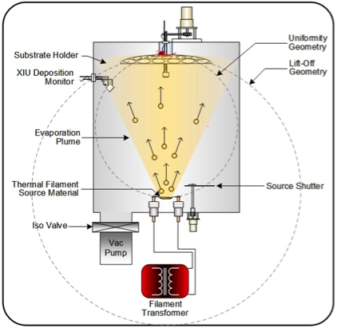

The environment in which thermal evaporation is carried out must be high vacuum. This is very important for a uniform deposition of metal of the surface of wafer. High vacuum assists thermal evaporation in following ways:

1. It reduces impurity atoms and air molecules that might also get deposited along with metal.
2. It reduces thermal transport to substrate.
3. It reduces the current required to convert metal to vapour since vacuum prevents heat loss.
4. Increases mean free path of collision of metal atoms in vapour phase. This ensures more metal atoms reach the substrate in uniform manner.

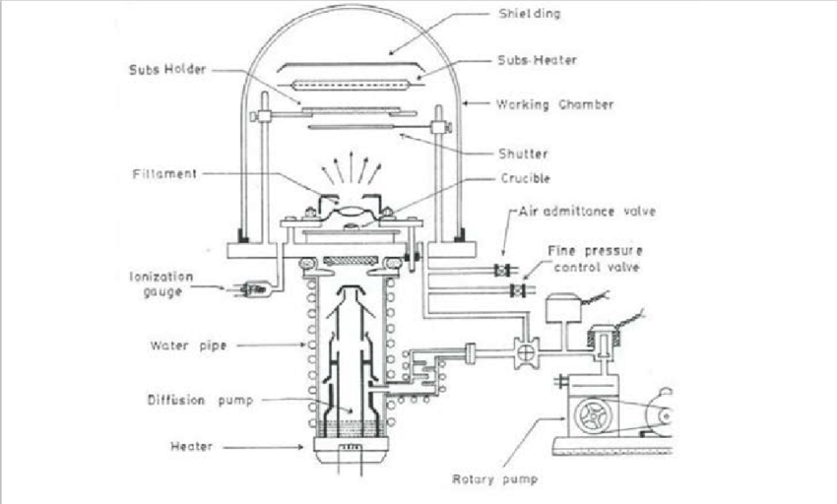

Metals used in Metallization

Any metal used for metallization must have the following properties:

1. Low resistivity, minimum junction penetration and low electromigration.
2. Mechanical stability, excellent cohesion and smooth surface.
3. Stable chemically and relatively stable in most chemical environment.
4. No interference with device.

Aluminium, copper, chromium, gold, silver, titanium and palladium are all easily deposited by thermal evaporation. **Aluminium** (Al) is the most commonly used metal in ICs, discrete diodes and transistors. This is because it provides following of the properties that helps in fabrication:

1. It has relatively good conductivity and is easy to deposit in thin films by thermal evaporation since it has a low melting point of about 600°C.
2. It has good adherence or cohesion to the SiO2 surface. It also forms good mechanical bonds with Si by sintering at 500°C or alloying at eutectic temperature of 577°C.
3. Al forms low-resistivity, ohmic contacts with p-type Si and heavily doped n-type Si.
4. It can be applied and patterned by a single deposition and etching process leading to faster fabrication.

Aluminium also has certain disadvantages that hinder certain aspects of metallization:

1. If the temperature becomes higher than 600°C then it may fuse and penetrate the oxide and cause short circuit.
2. Aluminium has a tendency to react with other metals present in devices like gold, forming intermetallic compounds. This, of course, degrades the device.
3. Aluminium suffers from electromigration which can lead to non-uniform surfaces since parts of the metal is transported away.

Patterning

Patterning is done in order to guard certain portion of the wafer from metal deposition. A shadow mask is used for this purpose. The shadow mask is first kept on top of substrate and then metal deposition is started. Metal gets deposited only in the holes of the mask to form fine patterns.

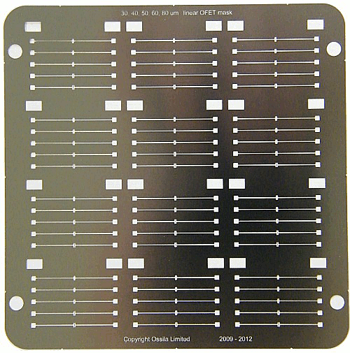

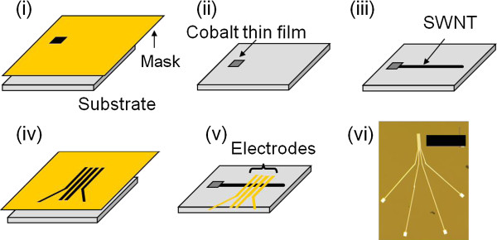

Procedure of Thermal Evaporation

Thermal evaporation deposition is carried out in following steps:

1. The device is switched ON and air is let into the thermal evaporator before the vacuum chamber is hoisted up.
2. The oxidised Si wafer is kept on the substrate holder with the polished surface facing downward on the evaporation source.
3. Al strips are loaded into the tungsten filament which is responsible for melting Al and vacuum chamber is closed.
4. The vacuum chamber is then evacuated:
   1. First only the **Roughing valve** is opened to take out the air vigorously and lower the pressure to 10-3 mbar.
   2. The **Diffusion pump** is switched on and the silicone oil is heated up. Pressure is measured with **Pirani Gauge**.
   3. After reaching the desired vacuum level the roughing valve is closed and the **Backing valve** is opened.
   4. After waiting some time, the **Baffle Valve** is opened till pressure reaches 10-6 mbar. In this regime, pressure is measured with the help of **Penning Gauge**.
5. Deposition is started by passing high current and the thickness of metal deposited is strictly monitored.
6. When desired thickness is reached, diffusion pump is switched off and baffle valve is closed. Air is let into vacuum chamber and the wafer is taken out from substrate holder.
7. The thickness of the metal deposition is again measured with the help of surface profilometer to better ascertain the thickness.

Observation

1. Deposition of metal on wafer gives it a shiny and glossy finish which can be easily confirmed by visual inspection.
2. The cohesion between metal and wafer surface is checked with the help of scotch tape. The cohesion is good if after peeling off the scotch tape, metal does not peel off along with the scotch tape.
3. The thickness of deposited metal is measured accurately with surface profilometer to check if the required thickness has been achieved.

Conclusion

1. The evaporation apparatus employs extremely cold liquid Nitrogen. This prevents the oil molecules from entering the chamber by cooling then down. Moreover, the extremely low temperature also helps in achieving vacuum easily since pressure is proportional to temperature.
2. Angle of arrival of metal vapour flux affects the coverage of wafer. To get a uniform deposition the wafer should be rotated.
3. Aluminium is prone to electromigration which can result in non-uniform deposition in high current regime.
4. Hillocks may be formed if the coefficient of thermal expansion of deposited metal is vastly different from the coefficient of thermal expansion of substrate.